Teaching and Learning Exploratory Video Curriculum
The Teaching and Learning Exploratory (https://tle.soe.umich.edu/) is an online video library of authentic teaching practice -- the exploratory houses 1500 + METX (Measures of Effective Teaching), as well as other collections, such as the Grand Rapids Elementary Mathematics Laboratory (GREML). The METX project enlisted more than 350+ teacher volunteers from six school districts, collecting video and other artifacts of everyday classroom activities that document thousands of lessons.

1. LOCATING YOUR VIDEOS
To log into the site go to:
https://tle.soe.umich.edu/
Username – first initial + last name. If your last name is fewer than 5 characters, utilize your full first and last name as your username.
*Passwords will be changed during the institute.
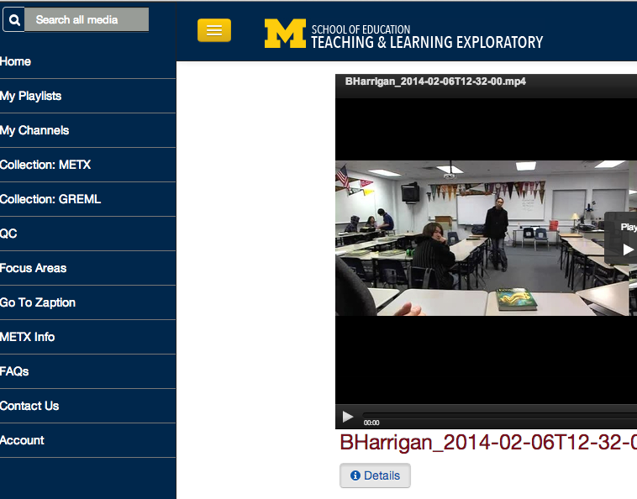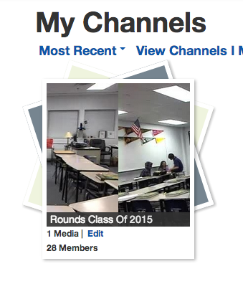
3. In this channel you will have private access to the classroom session from the Institute. Additionally, GREML has been added to your channel for your use. METX videos are also accessible for you through the gallery.
2. Choose the option to “Channels I am a member of”
1. My Channels is your private channel for video storage.

2. Getting the Video to Zaption For Clipping and Sharing

Find your video in the channel.
Add the video to a playlist, and then “publish” it to Zaption.
For more information on this process, watch the quick (just over 1 minute video) on how to create a playlist and publish to Zaption. These “HOW TO” videos are on the homepage of the exploratory. Here are links as well:

Making Playlists
Publishing to Zaption

3. CREATING A “TOUR” TO EDIT YOUR VIDEO

In order to edit and clip your video you must create a “Tour” – think of this as highlighting a portion of video/lessons.

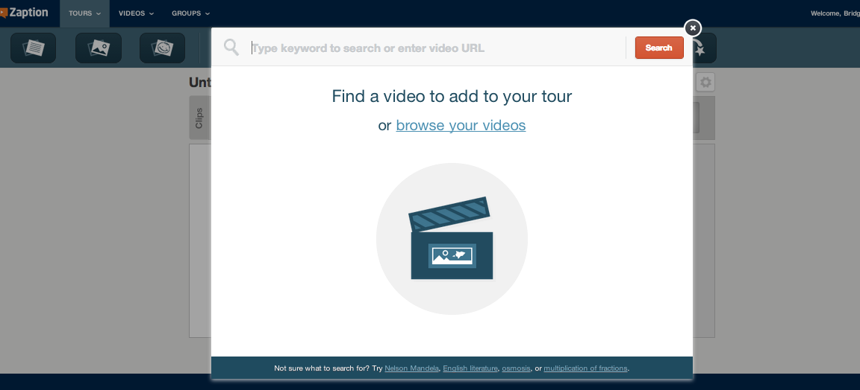

Create a tour, and then add your video by choosing videos from playlists or “my videos” into this “Tour.”

Your video will be under the search tool here, or you can add videos by “adding video” at any time on this tour.

4. INTERACTING WITH THE VIDEO IN ZAPTION
Once you have created your tour, you can start clipping and sharing your video.

Quick Steps for Clipping Video and Sharing:

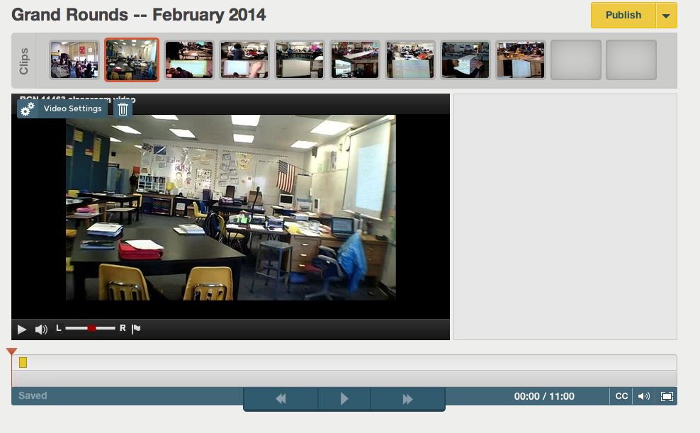
1. VIDEO SETTINGS TAB allows you to choose portion of the video for clipping with timestamps..

2. Publish the Tour and then 3. SHARE the tour with others in the TLE system.

Visit Zaption Help Center for details about tools and if you have questions.

You can SHARE this tour by adding email addresses of those in the TLE system to the Advanced Sharing settings. There are also ways to create “groups” in Zaption for easy “one click” sharing.

IMPORTANT: Others cannot see the tour unless you PUBLISH AND SHARE; you can also use this platform to present your clip to your class. The tour will remain accessible by shared users until you edit or “unpublish” the tour.
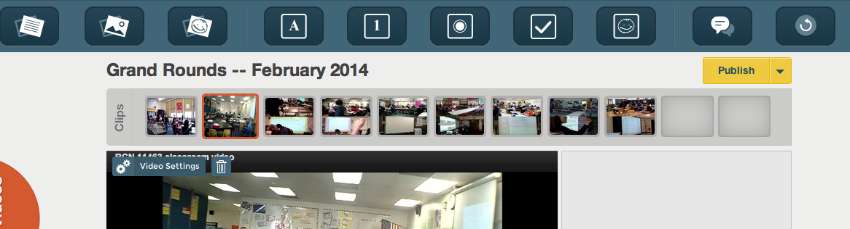
THE EDITING TOOLS ALONG THE TOP OF ZAPTION ALLOW YOU TO ADD COMMENTS, TEXT AND OTHER INTERACTIVE FEATURES TO YOUR VIDEO CLIP.

